

Promise Care Child Development Center’s
October 2023 News!
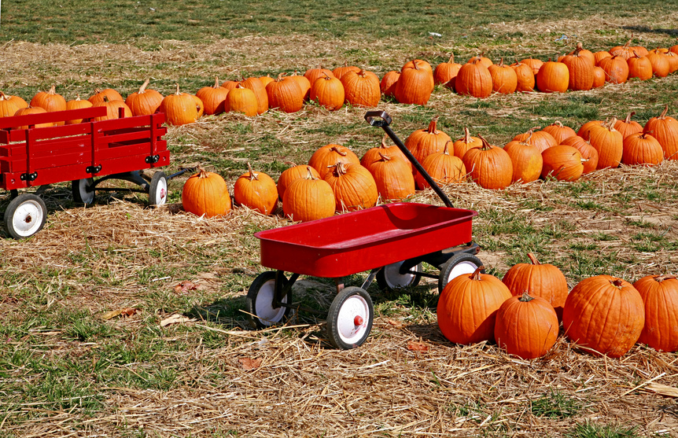
Director’s News

I would like to thank the entire Promise Care staff for a wonderful 2022-2023 school year. Good job and thank you for making Promise Care the best place for our children!
We are praying for a healthy and Blessed 2023-2024 school year ☺
Remember that tomorrow will always be better than today ☺
Please remember that our pumpkin patch field trip for PKI and PKII it’s on Tuesday October 24th …. Please be here no later than 8:30 a.m..... children need to pack lunch and only Ms. Andrea’s class needs to leave their car seats at the front because we don’t have enough for both classes.
PJ Day on October 13th …just come straight from bed 😊
Promise care will have its Fall Festival parties on Tuesday, October 31st at 3:30pm in their classrooms. The children will be able to dress in their costumes for the parties and we will be taking pictures of the children in costumes. We will send links for you to sign up to bring snacks to the party!
On October 31^{st,} please drop off no later than 9:30 a.m. because our trick or treating starts at 10:00 a.m. PLEASE COME IN DRESSED UP!!
Children will be going around to the Promise Care and church Offices for trick or treating….Parents are welcome to bring SNACKS FOR THE PARTY OR Candy and /or goodie bags for their child’s class but please make sure “ NOTHING IS HOMEMADE!!” Anything you bring needs to be individually wrapped!!!
Please bring a basket for your child’s trick or treating!!

Friendly reminder: please put in mind when you bring any treats or SNACKS for our parties that Promise Care is a peanut free facility!
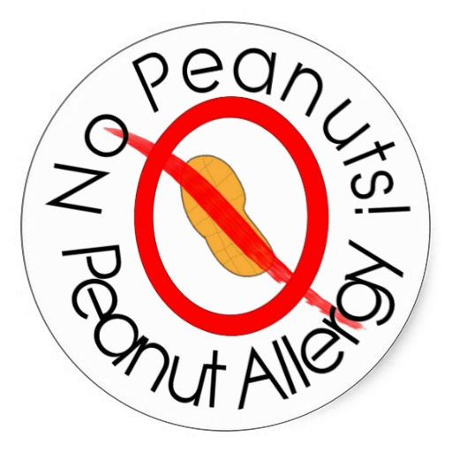
Please remember to pay your tuition Every Monday morning to avoid LATE FEES.
God bless you,
Neven Kalda- Director
October’s Birthdays

Ms. Tamara…….…. October 4th
Ms. Darqueta……. October 24th
Violet… A/S…. 10/02
Fabio….2’sII….10/15
Isadora….PK….10/11
Lorenzo…PK….10/22
Reese….PK….10/28
Ayune…A/S….10/25
Mila…2’sII….10/27
Richard …PKI…. 10/29

 Infant Insights
Happy Fall Festival Promise Care!
We are learning so much and growing so fast.
This month’s themes are Buses, Boats, cats, camels, Ducks, Dogs, Doctors, Dentist, and Pumpkins.
We can’t wait to see some cute baby costumes for the fall party!
Ms. Carol, Ms. Veronica, Ms. Raquel and Ms. Neek ❤
 Toddler Tidbits
We are happy to have you with us. Children have adjusted well in our classroom. The Toddler room got a lot of new toys to play with: farm animals, and food sets, talking cellphones, and books. During circle time the toddlers are currently working on ABC’s, Singing, shapes, colors and counting.
The Toddler room children have enjoyed decorating their room for the fall month with fantastic artwork displayed around the room. We can’t wait to dress up and enjoy trick or treating around the church offices. Dear parents, please remember to bring hats, coats, and gloves for the chilly days☺
God bless,
Ms. Lena and Ms. Tamara ❤
 Tales from the Two’s I
Welcome October! This month is a wonderful month of learning in our class. This month we will be learning about shapes, God made me and God loves me. Working on numbers 1-5 and Letters A-E
The 2’S class loves Art projects, so this month I have a lot of plans for them.
We are also going to dress up for our Fall Festival party and take lots of pictures. Please bring your child in their costume on Monday October 31st for all the fun
Love,
Ms. Rupal ❤
 Terrific Two’s II
Hello moms and dads,
This month our themes are demonstrating God’s love. We will be reviewing letters “A” and “B” while learning about our letters “C” and “D”.
We will also be reviewing our numbers 1 to 4. Our art projects will be filled with; buses, boats, cats, camels, doctors, dentists, Eskimo, and do not forget pumpkins.
Every day in the morning we read a bible story and learn about God’s love. Our Goal this month is to teach the kids “Who is God” … God created me and He loves me!!!!! Help us at home every night by praying with your child and tell them how much you love them!!!!
God has put us together to be Jesus little helpers, and with Christ we can do all things.
God bless,
Ms. Darqueta and Ms. Eirini
 Thrilling Three’s
Hello Parents,
We started the new school year strong and will finish strong😊
Praying for safety in Jesus’ name!!

We are working on our letters A through E and numbers 1 – 5. The children are enjoying craft time while learning to follow step by step directions.
The children are having a great time and can’t wait for October our wonderful fall month.
Love,
Ms.Tigist , Ms. Amani ,and Ms. Hannah H ❤
 Four I Facts
Hello parents,
Pre-k I had a great time in September and we cannot believe October is right around the corner! Last month we learned of the stories about God's creations and Adam & eve and were introduced to our letters, numbers, and colors. Happy Fall festival!! Don’t forget to wear creative costumes!!
This October, Pre-k
will learn more about our world and begin building our knowledge of numbers and letters. I am SO excited to see what our future holds!!
Praying for a safe new school year together! May God keep us all protected under the blood of Jesus and keeps you safe and stay blessed!!!

Love,
Ms. Andrea, and Ms. Hannah P ❤
Four II Facts
October is here and the school year is rolling along, we are off to a great start this year!!
This is our second month into the new school year, and most of the children are getting used to the new rules and schedules…. Good Job guys!!!
Working on using our words instead of whining as a way of expressing frustration…Please help me out at home ☺
We have soared through our shapes and colors and will continue exploring these topics as well as beginning our alphabet study. We will also be learning about the fun colors of fall through the changing leaves.
Happy Fall Festival!!
Please make sure you wear your costume for our Fall Festival party on Tuesday 10/31
We Can’t wait to make adorable pumpkins art.

Have a blessed month and be safe,

Miss Jennifer, Ms. Payal ❤



